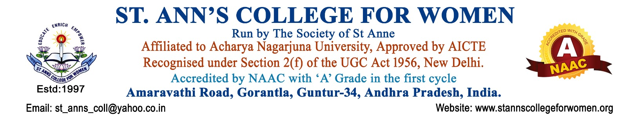

Quantum Innovation Centre
Guidelines & Procedures
1. Introduction
The Quantum Innovation Centre of St. Ann’s College for Women, Gorantla, Guntur is established to promote innovation, research, creativity, entrepreneurship, and skill development among students and faculty members.
The centre aims to create an innovation ecosystem within the institution by encouraging students to develop problem-solving abilities, innovative thinking, research aptitude, and industry-oriented skills in alignment with NAAC, UGC, and Andhra Pradesh Government initiatives for higher education and innovation.
2. Objectives
The Quantum Innovation Centre aims to:
- Promote innovation, creativity, and research culture among students and faculty.
- Encourage development of innovative ideas, prototypes, and projects.
- Organize workshops, seminars, hackathons, and skill development programs.
- Support entrepreneurship, start-up culture, and incubation activities.
- Facilitate collaboration with industries, research organizations, and innovation centers.
- Encourage participation in innovation competitions and research activities.
- Promote digital learning, emerging technologies, and interdisciplinary learning.
- Enhance employability, leadership, and problem-solving skills.
- Maintain records and documentation of innovation activities and achievements.
3. Constitution of the Centre
The Quantum Innovation Centre shall consist of:
- Principal – Chairperson
- Innovation Centre Coordinator
- Faculty Members
- Research Coordinator
- IQAC Representative
- Industry / Alumni Experts
- Student Innovation Representatives
4. Roles and Responsibilities
The centre shall:
- Plan and organize innovation and research activities.
- Encourage students to participate in innovation projects and competitions.
- Conduct workshops on emerging technologies and entrepreneurship.
- Coordinate industry interaction and collaborative activities.
- Guide students in project development and start-up initiatives.
- Promote research publications, patents, and creative work.
- Maintain records, reports, and documentation of activities.
5. Procedures
Step 1: Planning
- Prepare annual activity plan for innovation and skill development programs.
Step 2: Awareness Programs
- Conduct seminars, workshops, webinars, and awareness sessions on innovation and entrepreneurship.
Step 3: Student Participation
- Encourage students to participate in:
  - Research projects
  - Hackathons
  - Innovation challenges
  - Skill development programs
  - Start-up activities
Step 4: Collaboration
- Coordinate with industries, institutions, incubation centers, and government agencies.
Step 5: Documentation
- Maintain records of:
  - Activities conducted
  - Student participation
  - Innovation projects
  - Awards and achievements
  - Collaborations and MoUs
6. Major Activities
The Quantum Innovation Centre may organize:
- Innovation and Entrepreneurship Workshops
- Research and Project Exhibitions
- Start-up Awareness Programs
- Coding and Technology Training
- Design Thinking Sessions
- Industry Interaction Programs
- Skill Development Activities
- Innovation Competitions and Hackathons
7. Documentation and Records
The centre shall maintain:
- Committee Constitution
- Annual Activity Plans
- Attendance Registers
- Activity Reports
- Innovation Project Records
- Student Achievement Records
- Photographs and Media Reports
- MoUs and Collaboration Records
- Annual Reports
8. NAAC, UGC & AP Government Compliance
The Quantum Innovation Centre functions in alignment with:
- NAAC Innovation and Best Practices Framework
- UGC Skill Development and Research Initiatives
- Andhra Pradesh Government Higher Education and Innovation Policies
- Student-Centric and Outcome-Based Education Practices
The centre contributes to:
- Innovation and Research Culture
- Skill Development
- Entrepreneurship Promotion
- Industry Interaction
- Student Employability
- Institutional Quality Enhancement
9. Expected Outcomes
The activities of the centre are expected to:
- Enhance innovation and research skills among students.
- Promote entrepreneurship and start-up culture.
- Improve creativity, leadership, and problem-solving abilities.
- Strengthen industry-academia collaboration.
- Encourage interdisciplinary and experiential learning.
10. Conclusion
St. Ann’s College for Women, Gorantla, Guntur is committed to fostering innovation, creativity, and research-oriented learning through the Quantum Innovation Centre. The centre plays a vital role in preparing students to become innovative thinkers, skilled professionals, and socially responsible citizens in alignment with NAAC, UGC, and Andhra Pradesh Government quality initiatives.

